**IBM Cloud – Post Login**

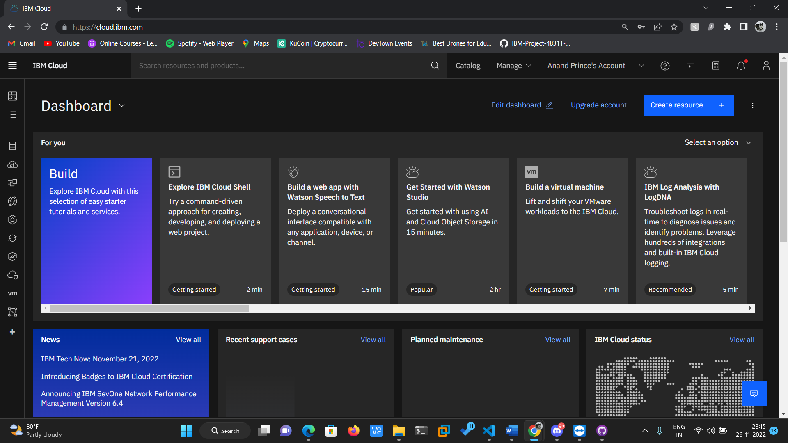

**IBM Cloud – Cloudant Service Instance**

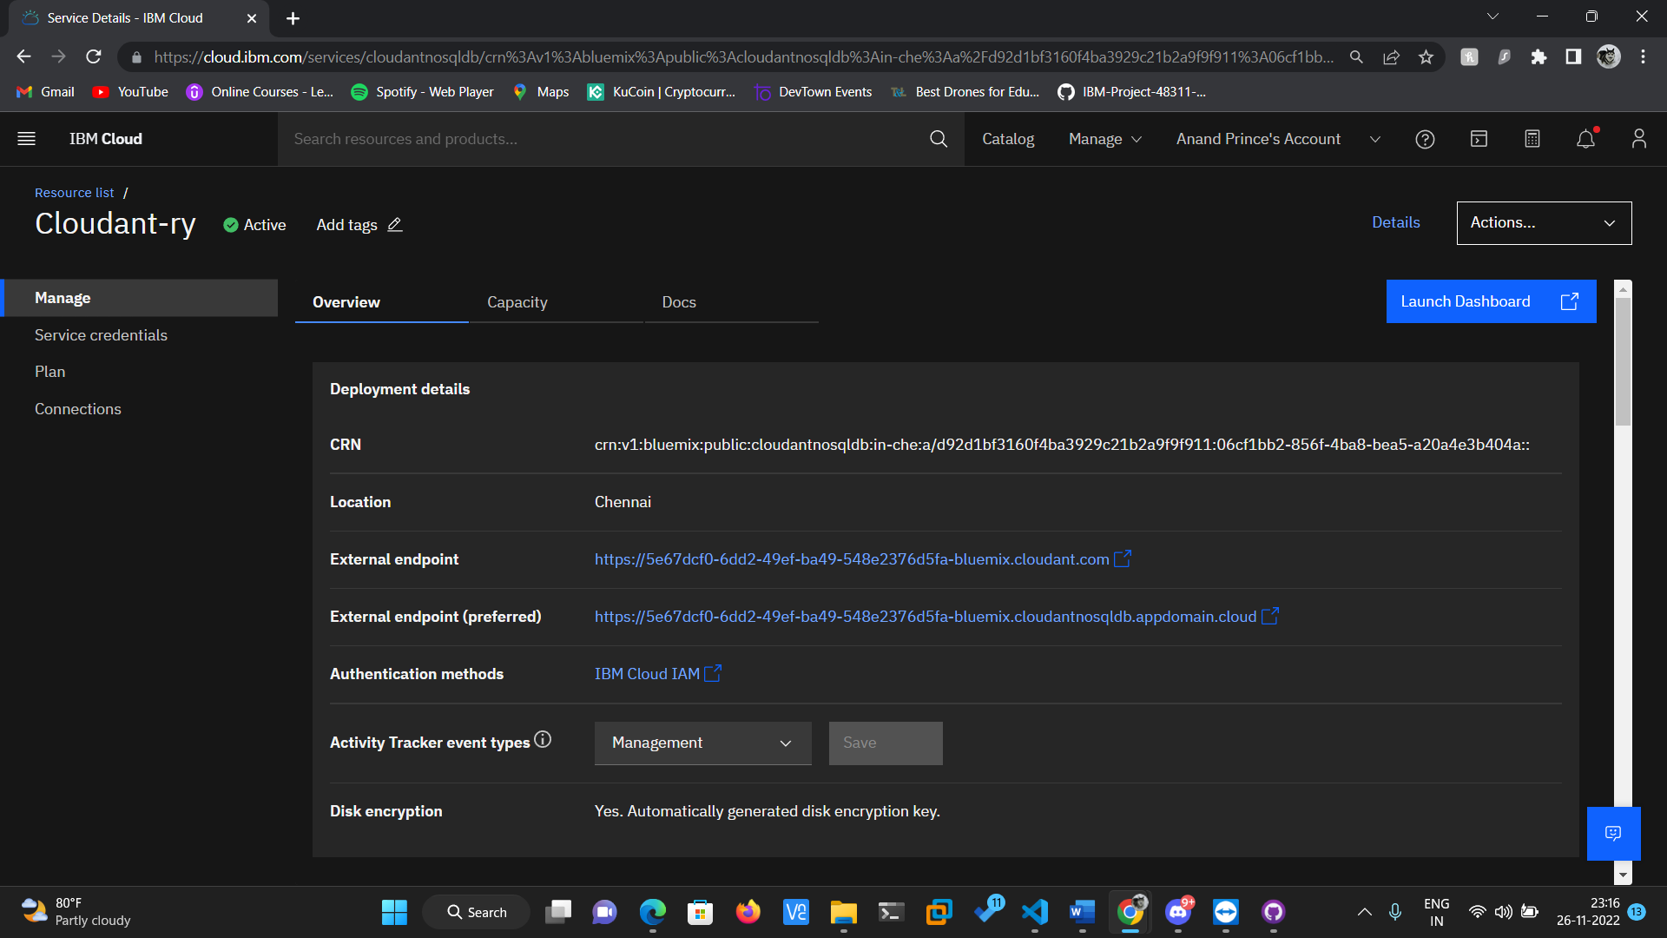

**Cloudant Service Instance – Launching Dashboard & Creating Databases**

